**Development and Implementation of Weather Research Forecasting Model-based Winter Storm Severity Index (SSI) for Proactive Response to Transportation Emergency in Oklahoma**

Trevor Grout1, Yang Hong1, Balabhaskar Balasundaram2, Zhenyu Kong2, Satish T. S. Bukkapatnam2

1 School of Civil Engineering and Environmental Science and the Atmospheric Radar Research Center, University of Oklahoma, OK 73072

2 School of Industrial Engineering and Management, Oklahoma State University, OK 74078

Development and Implementation of Weather Research Forecasting Model-based Winter Storm Severity Index (SSI) for Proactive Response to Transportation Emergency in Oklahoma (Tentative Title)

Abstract (incomplete but can come back later)

Need background and motivation sentence. A storm severity index was developed, geared specifically toward transportation, for classifying winter storms in Oklahoma. This storm severity index was designed to be used with advanced numerical weather prediction models such as Weather Research and Forecasting model or the Short Range Ensemble Forecast model. Because this Storm Severity Index utilizes these advanced weather models it is both a distributed and dynamic index which reflects the evolving severity of an Oklahoma winter storm as a function of space and time.

This index is the summation of two separate indices (base and precip) which evaluate important non-precipitation and precipitation based weather parameters. These weather parameters include precipitation intensity, visibility, accumulation, wind-speed, and temperature and were chosen based on their impact on transportation.

Need mention implementation and calculation of the SSI over the past 10+ years and what is the general conclusion?

Mention that the SSI, as one critical input, will be integrated into transportation resource optimization system. We expect that this integrated system will provide decision makers with an accurate forecast of which locations will be most heavily impacted during severe winter weather so they can make informed decisions regarding the allocation of resources.

# Introduction

During the past 50 years [1] large-scale disruptions due to extreme winter weather events, especially ice storms, have cost in excess of $45 billion on the nation’s infrastructure; and winter maintenance approximately accounts for 25% of State Departments of Transportation (DOTs) budgets. Nationally, there have been 33 Presidential disasters declared because of snow and ice since 2000 [2]. According to Federal Highway Administration (FHWA) statistics [3], State and local agencies spend more than $2.5 billion on snow and ice control operations and more than $5 billion to repair infrastructure damage caused by ice and snow. In the period 1995–2004, more than 389,000 crashes occurred in winter weather (6% of all crashes), more than 133,000 persons were injured in winter weather (more than 4% of all crash injuries) and more than 1,500 people were killed in crashes during winter weather (more than 3% of all crash fatalities). Adverse weather is recognized as one of the leading causes of non-recurrent congestion, and in particular winter precipitation alone can cause 15% of non-recurring delay. The cost of congestion related travel delays on an economy is significant. It has been estimated that in metropolitan areas, truckers lose about $3.4 billion (about 32 million hours) stuck in weather-related traffic delays. A one-day highway shutdown can cost a metropolitan area up to $76 million in lost time, wages, and productivity [4]. Consequently, various state DoTs have been striving for effective maintenance and response policies to mitigate hazard in the event of extreme winter weather as part of their winter preparedness programs [5-10].

Weather data is imperative to the decision making processes during severe winter weather. To allow for effective decisions to be made over large geographic regions weather data must be gridded instead of point based. To maximize preparedness weather data must be forecast for some reasonable time into the future (2-3 days). From a meteorological standpoint these requirements are met through advanced weather prediction models such as the Weather Research and Forecasting model (WRF) and the Short Range Ensemble Forecasting (SREF) model. Although weather models are ideal for improving preparedness they can require extensive background knowledge in meteorology to be useful and therefore it is important to present model output so that transportation managers can focus on making decisions instead of learning models. This goal can be accomplished by developing winter severity indices tied to specific sectors of the economy.

There have been several indices developed recently and Maze et al. [11] contains a brief summary of many of these. Many earlier indices rank entire winter seasons using daily temperature and snow data [12-14]. Some of these indices even factor in multiple precipitation types [15-17]. Nearly all of these earlier storm indices were developed using observed data and were applied to the entire winter season. Maze et al. [11] notes a more recent index [18] which is storm based and includes factors such as temperature, wind, and storm behavior. Other storm based indices have been developed for specific types of precipitation such as the Nor’easter intensity index [19] or the Sperry-Piltz [20] ice accumulation index which categorizes ice storms according to ice accumulation and wind. Many of the existing indices are applied to winter seasons and not applied to individual storms or they are based on observed data and not advanced numerical weather prediction models. Furthermore, these indices are static and are not designed to be updated dynamically as the storm data is gathered and forecasts are updated. Because winter storms affect different sectors of the economy differently, it is important to tune an index to a specific sector. For example, the Sperry-Piltz ice accumulation index applies to the electrical grid and utility infrastructures and is hence used by utility managers. There are no known indices which utilize advanced numerical weather prediction models and are tailored specifically to transportation maintenance operations to classify individual storms (very good motivation for this study, might put into the Abstract).

# SSI Development

A transportation-specific, storm-based, dynamic, distributed, Storm Severity Index (SSI) which accounts for all major winter precipitation types (rain, snow, sleet, and freezing rain) was developed. It was designed to be compatible with multiple forecast predication models such as the Weather Research and Forecasting model (WRF) [21] or the Short-Range Ensemble and Forecast (SREF) model[22]. Both of these models are advanced weather prediction models which predict weather conditions from two to three days in advance. The WRF model has a higher resolution and more frequent time steps and produces forecasts out to two days. The SREF is an ensemble model consisting of over a dozen weather models and the mean of these models is used for the calculation of the SSI it has a coarser resolution than the WRF but it forecasts for up three days in advance.

Using weather parameters produced by weather prediction models the SSI is specifically formulated for transportation and other road interests by accounting for precipitation intensity and visibility, precipitation accumulation, as well as other non-precipitation hazards such as the winds, temperature, and temperature trend. The SSI was developed similar to Boselly et al.[13] with weather parameters assigned categorical scores and then weighted relative to other parameters. The SSI is composed of two sub-indices which rate important non-precipitation parameters (Base Index) and important precipitation parameters (Precip Index). The Base Index parameters are skin temperature, temperature trend, and windspeed; while the Precip Index parameters are precipitation impact on free flow traffic speed (a function of precipitation type, intensity, and visibility) and precipitation accumulation. The total SSI is then the sum of both indexes. This SSI is unique because it is a dynamic and gridded storm based index which is tailored specifically to transportation. The SSI quantifies weather impacts on free flow traffic speed caused by both precipitation intensity and precipitation accumulation. In addition, it can be used with multiple advanced numerical weather prediction models (WRF or SREF) which can be used for both forecasting and hindcasting purposes. Because this SSI is used with numerical weather models it has the same time step (typically 3 hours) and resolution (as low as 1km) as the weather prediction model used. All parameters in both indices are divided into categories with each parameter category assigned a score (from 0 to 1) based on severity. Additionally, each parameter is given a weight (from 0 to 100%) so that they can be given a relative significance compared to the other parameters within each index. All parameter weights within an index must sum up to 100%, thus the index score can have a maximum score of 100. The index score is the sum of the products of the parameter’s categorical scores’ and that parameter’s weight. The mathematical formula (Equation 1) for each index is represented as:

$$Index(maximum 100)= \sum{[\left(Parameter category score \right)×(Parameter Weight })]$$

The SSI is only calculated during storm conditions, or when precipitation is forecast to begin until 24 hours after all precipitation has ended. Once a storm is over, the SSI resets to zero and is not calculated until precipitation is forecast to begin again. The 24 hour period assumes that the emergency response to high-impact winter storms will be completed within 24 hours after the last predicted winter precipitation falls.

## Base index

The first index is the Base index (Figure 1) which consists of three important non–precipitation parameters (surface temperature, temperature trend, and wind speed) which impact winter storm severity. Surface temperature is important because it is the ground temperature and thus the closest approximation to the pavement temperature. Temperature trend is important because it indicates if the temperature is decreasing (more severe) or increasing (less severe). Finally, wind speed is included because it can influence traffic conditions as velocities increase. Calculation of the base index involves assigning a score to each weather parameter (between 0 and 1) as well as a parameter weight (summed to 1) (Table 1) (Figure 1).

**TABLE 1 Adapted from Kyte et. al [****23****] who quantified wind impacts on driving conditions in free flow speed**

|  |  |  |  |
| --- | --- | --- | --- |
| **Index** | **Parameter** | **Weight (%)** | **Score (0 - 1)** |
| **BASE** | Temperature | 40 | Above Freezing (1), Below Freezing (0) |
| Temperature Trend | 10 | Increasing (0), Decreasing (1) |
| Windspeed1 | 50 | Windspeed < 10 mph (0);  16mph ≤ Windspeed ≤ 20 mph (0.33) 20 mph < Windspeed ≤ 30 mph (0.66) Windspeed > 30 mph (1) |
|  | | | |

In addition, wind speeds become critically important over snow covered surfaces as high wind speeds can cause blowing snow, thus reducing visibilities to as low as zero and deteriorating traffic conditions. Li and Pomeroy [24] describe a method for determining wind speeds above which blowing snow is possible. This method is only applicable to ‘dry’ snow, or snow which has not been exposed to melting temperatures or additional liquid precipitation. Although this is not always the case, for simplicity, it will be assumed this is the case for all snow events in Oklahoma. If snow was forecast to be on the ground and wind speeds were found to be above the blowing snow threshold for a particular grid then a revised base index is calculated(Figure 1).

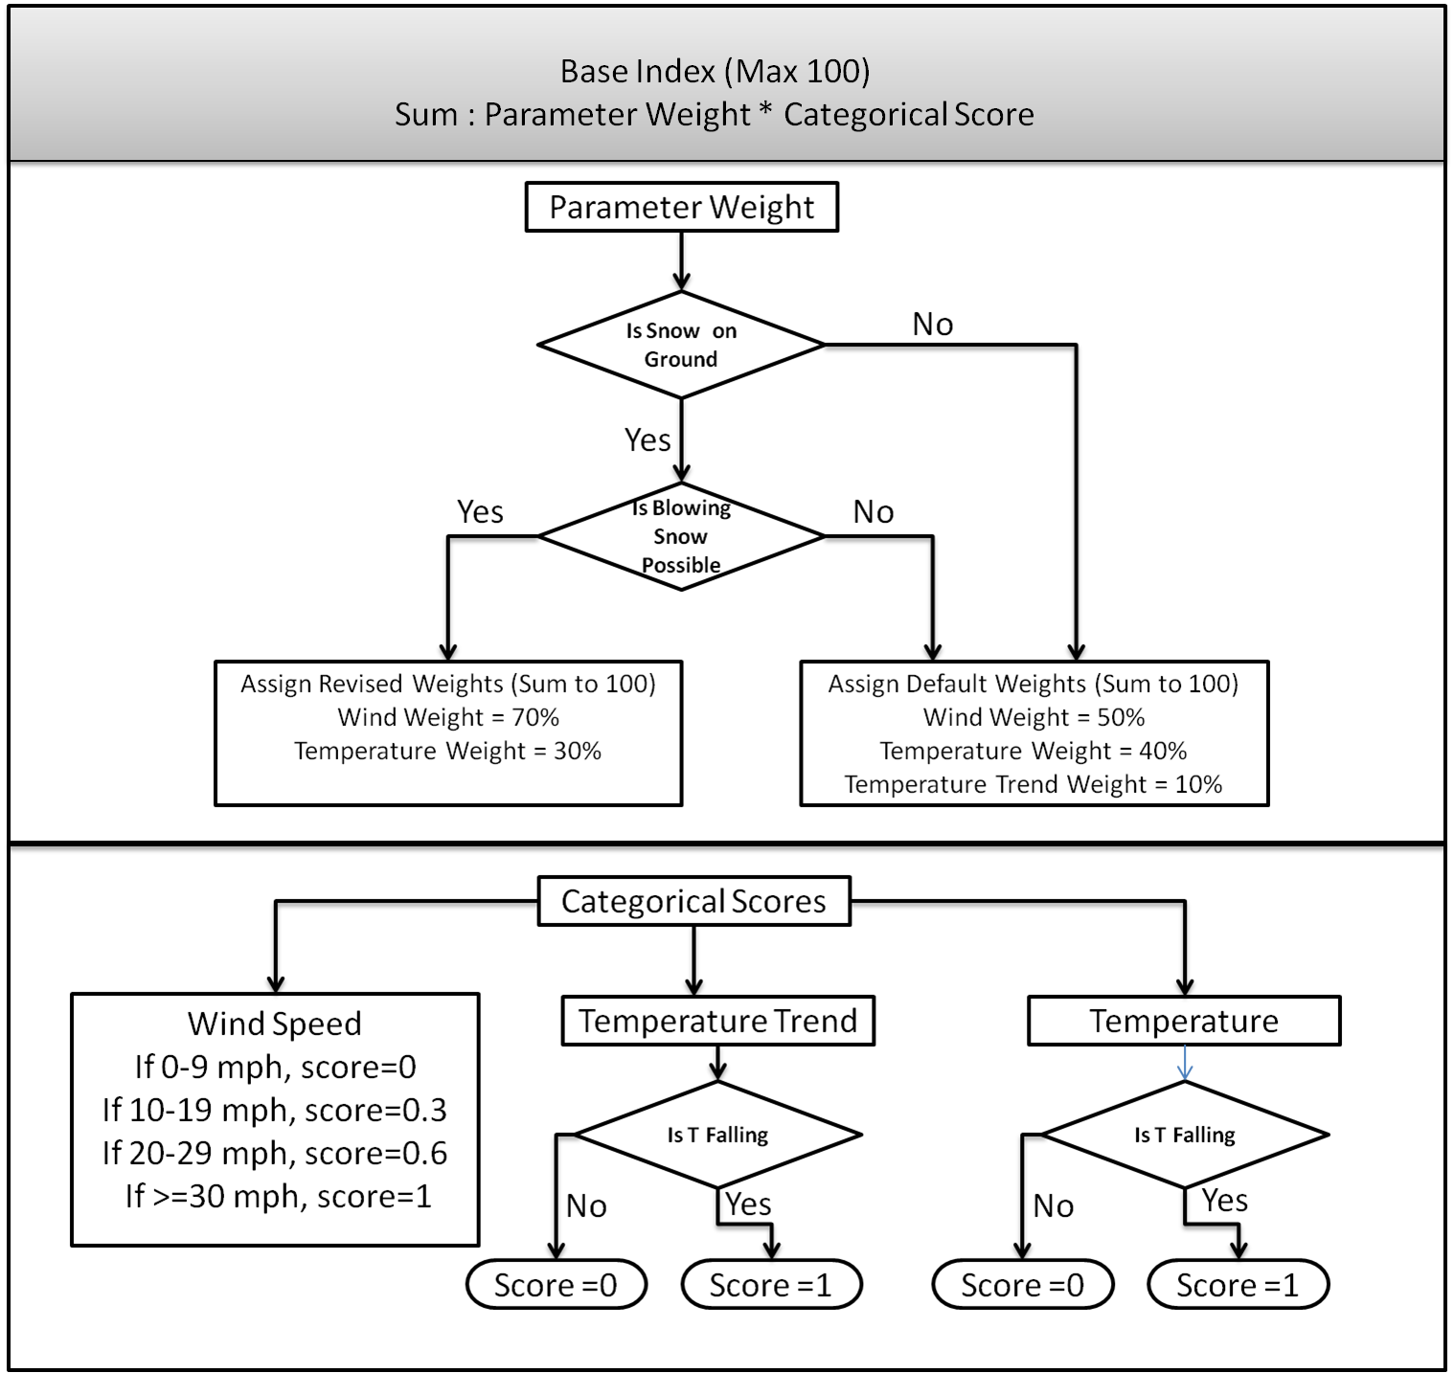

FIGURE 1 Flowchart for Base Index. Base index score is calculated by multiplying the parameter weight with the parameter score. Max score is 100.

## Precip Index

The Precip index (Figure 2) consists of important precipitation based parameters and their impact on transportation. The first parameter is storm total precipitation accumulation. Precipitation accumulation severity is dependent upon the precipitation type; one inch of snow is not as severe as one inch of ice. The second parameter describes the impact of precipitation on free flow traffic speed. This parameter incorporates precipitation type, intensity, and visibility and quantifies the impact on traffic flow.

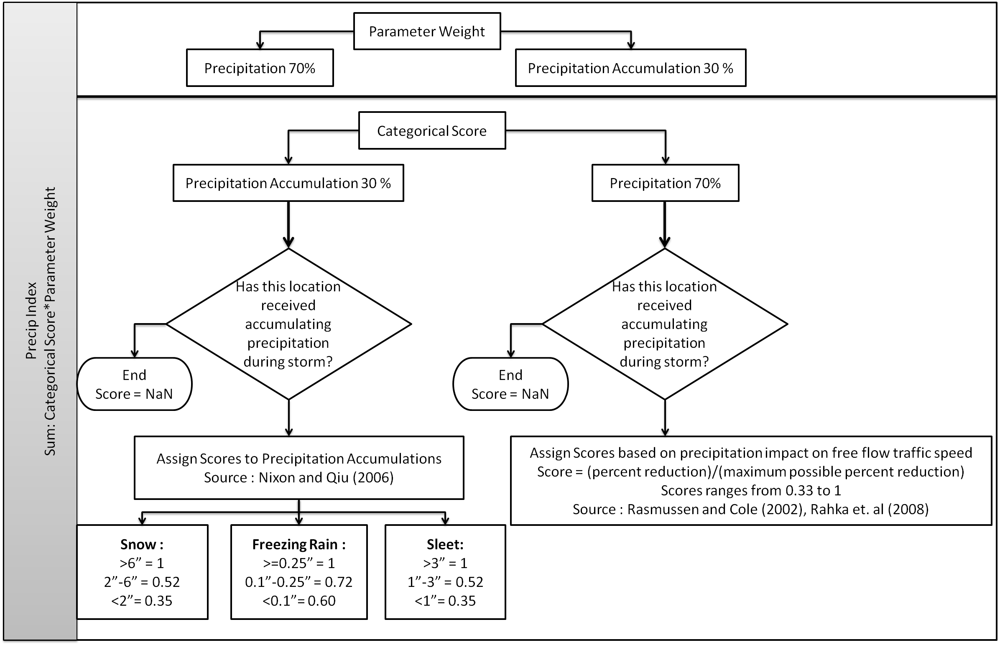

FIGURE 2 Flowchart for Precip Index. Precip index score is calculated by multiplying the parameter weight with the parameter score. Max score is 100.

The Precip index consists of two parameters: precipitation accumulation and precipitation intensity effect on free flow traffic speed. The scores and weights assigned each parameter are given below:

### Precipitation Accumulation

Accumulation scores were adapted or slightly modified from Nixon and Qiu [18] who quantified the relative impact of winter storm accumulations on transportation for different precipitation types. All precipitation estimates are calculated using liquid equivalent amounts. All freezing rain amounts are radial equivalent accumulations according to the method described by Jones [25]. Snow and sleet amounts were derived using general conversions from liquid equivalent amounts [26, 27].

### Precipitation impact on Free Flow Traffic Speed

This parameter incorporates precipitation intensity and visibility. Categories for this parameter are numerous but they are all based upon visibility, intensity, and precipitation type. This parameter is weighted more than accumulation as precipitation intensity is more impactful on transportation than storm accumulations.

**Snow and Slee**snow and sleet have the highest impact on visibility. Average liquid-equivalent hourly snowfall/sleet rates are calculated from model output and intensities are assigned according to Rasmussen and Cole [28]. Visibility (a function of precipitation intensity), temperature, and time of day, were assigned according to Rasmussen and Cole [28]. Rakha et al. [29] studied how precipitation impacts free-flow traffic speed; it is a function of precipitation intensity and visibility. Intensities and visibilities determined from Rasmussen and Cole [28] were applied to Rakha et al [29] to determine the impact of precipitation intensity on free flow traffic speed. Scoring was the ratio of the impact on free-flow traffic speed to the maximum possible impact on free-flow traffic speed.

**Rain/ Freezing Rain**According to Rassmussen and Cole [28], liquid precipitation does not impact visibilities near as much as snowfall. Rakha et al. [29] does quantify rainfall intensities on free flow traffic speed. Unfortunately, freezing rain’s impact on free flow traffic speed is not well studied and accurate impacts on free flow traffic speed are not available. To account for freezing rain it was assumed that for any three hour period, or time step of the model, if a location was forecast to experience freezing rain with radial ice accumulations greater than .01” then that location would receive a maximum score of 1. This may be excessive, but the impact of freezing rain cannot be overemphasized.

# SSI Implementation and preliminary Evaluation

**SSI Implementation over 2000-2010 Winter Seasons**

A WRF model was run in-house for all winter seasons (December to March) from 2000 – 2010 for central Oklahoma. SSI scores for each grid were accumulated on a 12 hourly and daily basis and they yielded a log-normal distribution (Figures 3,4).

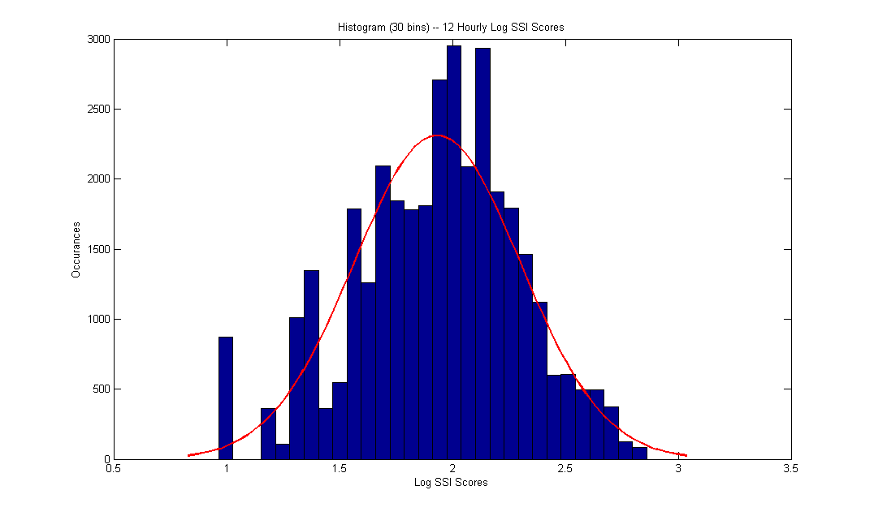

FIGURE 3 SSI distribution on a 12 hour basis.

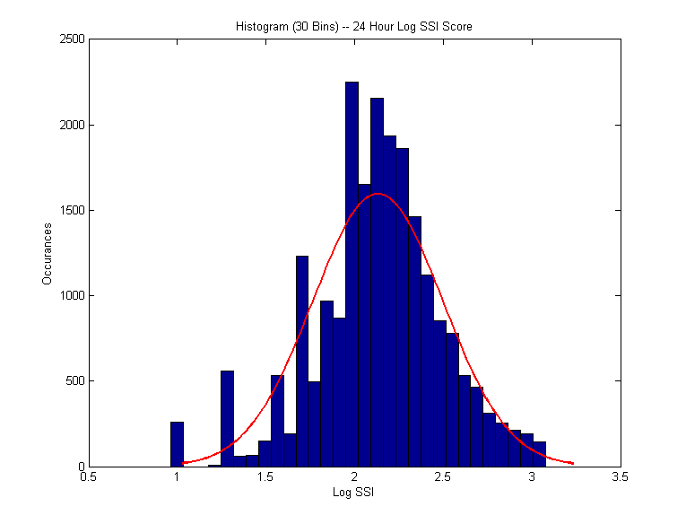

Figure 4 SSI distribution of SSI scores on a daily basis

An addition, a statewide WRF model was run for some major disaster storms of the past decade in Oklahoma. These model runs are compared to the disaster declaration plots also as shown in Figure 5.

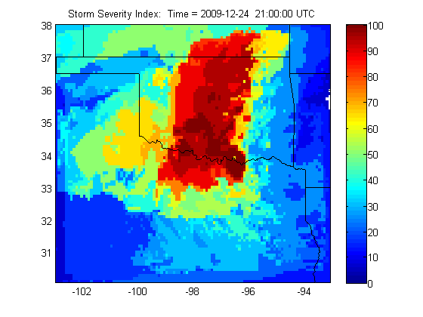

Figure 5 Storm Severity Index for a winter related major disaster in December, 2009

**SSI Preliminary Evaluation**

To evaluate the SSI, daily accident data including injuries and fatalities, for Oklahoma county for 10 winter months (from 2000 – 2010) was obtained from the Oklahoma Department of Transportation. Effect of SSI to number of accident is investigated to by using ANOVA. Following hypothesis is examined to observe weather SSI is related with the number of accidents or there is no relationship.

$H_{0} :There is no relationship with SSI and the number of accidents$

$H_{1} :There is a relationship with SSI and the number of accidents$

SSI is calculated for the whole day and separated into 3 categories. First 50 percentile is categorized as light storm, between 50 and 75 percentile is medium and 75 to 100 is categorized as severe storm. The model is constructed as follows:

$$N=a+b*WC$$

where is *a* and *b* are the constants, *N* is the number of accidents and *WC* is the weather condition. *WC* is considered as ordinal variable assigned scores 0, 1, 2 and 3 to no storm, light, medium and severe respectively.

The results of the regression ANOVA is depicted in Table 2

**TABLE 2 Regression ANOVA for precipitation index and SSI**

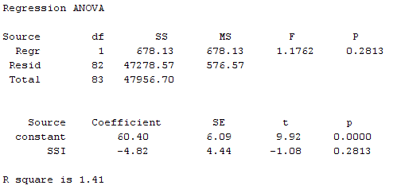

a)SSI

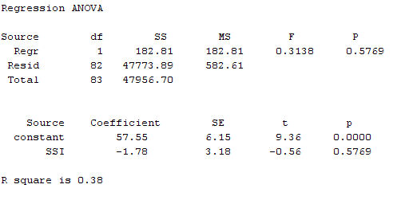

b)Precipitation Index

Both R square and p-value for F statistics suggests that although SSI model is better, both models are not adequate when we set the alpha value to 0.01. Regression ANOVA shows that the storm condition at that day is not an important factor that affects the number of accidents.

Our analyses show that previous day’s weather condition is an important factor that affects the number of accidents. Hence, the new regression model is constructed as follows:

$$N=a+b*{WC}_{t}+c*{WC}_{t-1}$$

where a, b, c, and d are constants, *N* is the number of accidents, ${WC}_{t}$ is today’s weather condition, ${WC}_{t-1}$ is yesterday’s weather condition.

The results of the regression ANOVA for the enhanced model is depicted in Table 2

**Table 3 Regression ANOVA of the enhanced model for precipitation index and SSI**

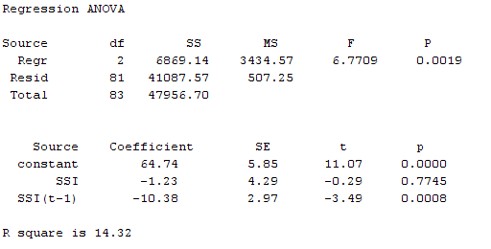

1. Precipitation index

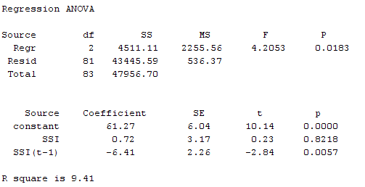

1. SSI

Table 3 shows the regression ANOVA for the new model. When alpha value is set to 0.01 for the precipitation index we fail to reject the null hypothesis which is there is no relationship with the weather condition and the number of accidents but for SSI we reject the null hypothesis and accept the alternative hypothesis concluding that weather condition affects the number of accidents.The r square value for SSI is better than precipitation index

# Conclusion

A storm severity index was developed geared specifically toward transportation. The SSI employs a novel approach to enable transportation officials to be better prepared for impending winter weather. This approach is an improvement from other severity indices because it is a storm based index which is both gridded and dynamic. The SSI is advantageous because it incorporates multiple weather parameters which influence transportation safety. In addition, using advanced weather prediction models enables the SSI to be calculated for both past and present winter events. By using a gridded and predictive SSI, DOT’s can anticipate severe winter weather and they can keep up with rapidly changing weather conditions as these weather models update, thus saving time and money. As weather prediction models improve in accuracy so will the SSI. The SSI shows some reasonable skill in correlating with accidents and this could be improved further as social influences, such as holidays, are better accounted for. Further studies on a national scale indicating impact of precipitation on other transportation parameters could be useful in improving the SSI.

**Acknowledgements**

This project was funded by the Oklahoma University Transportation Center project number OTCREOS9.1-02. In addition, David Andra, Science and Operations Officer at the Norman NWS office, was helpful in obtaining storm type definitions for forecast offices throughout Oklahoma. The authors also acknowledge and thank the anonymous reviewers whose input and constructive comments during the peer-review process greatly improved and enhanced this manuscript.

## References

1. Changnon, S.A., *Trend Analysis: Are Storms Getting Worse?* Weatherwise, 2010. **63**: p. 38-43.

2. FEMA. *Presidential Disaster Declarations: 10 January 2000 - 1 January 2010*. [PDF] 2011 [cited 2011; Available from: <http://www.gismaps.fema.gov/recent.pdf>.

3. Administration, F.H. *Priority, Market-Ready Technologies and Innovations*.

4. Administration, F.H. *Road Weather Management*.

5. of Emergency Management, O.D. *State Emergency Operations Plan (EOP)*. 2007.

6. Transportation, C.D.o. *Winter Maintenance*. [cited 2011; Available from: <http://www.coloradodot.info/travel/winter-driving/faqs.html>.

7. Transportation, I.D.o. *Winter Driving Safety*. [cited 2011; Available from: <http://www.in.gov/indot/2795.htm>.

8. Transportation, V.D.o. *VDOT prepares for winter*. [cited 2011; Available from: <http://www.virginiadot.org/newsroom/snowseason.asp>.

9. Transportation, W.S.D.o. *Snow and Ice Plan*. [cited 2011; Available from: <http://www.wsdot.wa.gov/winter/SnowIcePlan.htm>.

10. Transportation, D.o. *New ideas for a nation on the move*. 2008 [cited 2011; Available from: <http://www.dot.gov/stratplan2011/dotstrategicplan.pdf>.

11. Maze, T.H., C. Albrecht, and J. Wiegand. *Performance Measures for Snow and Ice Control Operations*. 2007.

12. Hulme, M., *A New Winter Index and Geographical Variations in Winter Weather.* Journal of Meteorology, 1982. **7**: p. 294-300.

13. Boselly III, S.E., et al., *Road Weather Information Systems, Volume 1*. 1993, Strategic Highway Research Program, National Research Council: Washington, D.C.

14. Rissel, M.C. and D.G. Scott, *Staffing of Maintenance Crews During Winter Months.* Transportation Research Record, 1985. **1019**: p. 12-21.

15. Audrey, J., J. Li, and B. Mills, *A Winter Index for Benchmarking Winter Road Maintenance Operations on Ontario Highways*, in *Proceedings of the 2001 Annual Meeting of the Transportation Research Board*. 2001, Transportation Research Board: Washington, D.C.

16. Carmichael, C.G., et al., *A Winter Weather Index for Estimating Winter Roadway Maintenance Costs in the Midwest.* Journal of Applied Meteorology, 2004. **43**(11): p. 1783-1790.

17. McCullouch, B., et al., *Indiana Winter Severity Index*, in *Paper presented at the Sixth International Symposium on Snow Removal and Ice Control Technology*. 2004, Transportation Research Board: Spokane, Washington.

18. Nixon, W.A. and L. Qiu, *Developing a Storm Severity Index*, in *Paper presented at the 2004 Annual Meeting of the Transportation Research Board*. 2004, Transportation Research Board: Washington, D.C.

19. Zielinski, G., *A Classification Scheme for Winter Storms in the Eastern and Central United States with an Emphasis on Nor'easters.* Bulletin of the American Meteorological Society, 2001. **83**(1): p. 37-51.

20. McManus, G., et al., *Development and Testing of an Ice Accumulation Algorithm*, in *17th AMS Conference on Applied Climatology*. 2008, American Meteorological Society.

21. WRF. *About the Weather Research and Forecasting Model*. [cited 2011; Available from: <http://www.wrf-model.org/index.php>.

22. SREF. *Short-Range Ensemble Forecasting*. [cited 2011; Available from: <http://www.emc.ncep.noaa.gov/mmb/SREF/SREF.html>.

23. Kyte, M., et al. *Effect of environmental factors on free-flow speed*. in *Transportation Research Circular*. 2000.

24. Li, L. and J.W. Pomeroy, *Estimates of threshold wind speeds for snow transport using meteorological data.* Journal of Applied Meteorology, 1997. **36**(3): p. 205-213.

25. Jones, K.F., *A simple model for freezing rain ice loads.* Atmospheric research, 1998. **46**(1-2): p. 87-97.

26. Jackson, J. *All About Mixed Winter Precipitation*. [cited 2011; Available from: <http://www.erh.noaa.gov/rnk/Newsletter/Fall_2008/mixed_precip/Mixed_precip.html>.

27. Center, N.C.D. *Estimating the Water Equivalent of Snow*. [cited 2011; Available from: <http://www.ncdc.noaa.gov/oa/climate/conversion/newsnowfall.pdf>.

28. Rasmussen, R. and J.A. Cole. *How snow can fool pilots*. 2002 [cited 2011; Available from: <http://www.rap.ucar.edu/projects/wsddm/SNOFOOL.pdf>.

29. Rakha, H., et al., *Inclement Weather Impacts on Freeway Traffic Stream Behavior.* Transportation Research Record: Journal of the Transportation Research Board, 2008. **2071**(-1): p. 8-18.

30. Evans, K., *Oklahoma Department of Transportation Accident Statistics for Oklahoma*, T. Grout, Editor. 2010.